Final Project: Pick a Project
Computer Science - Week 10
Oct 3, 2026 - Version 0.0.2
Please make sure to your UD email AND name is below. Unless your UD emails are included in this table, then you will not earn any points for this assignment when it is graded! Every person should submit their own individual worksheet.

Talk about each of the questions with a friend or our LLM (or both), but make sure the words you enter below are yours (with the obvious exceptions notwithstanding). Brainstorming is best done in full sentences, and the main goal here is brainstorming. It's worth reviewing the information in this series of pages in the Drafter documentation to gain a better understanding of the process.

Role | Name | Email
Developer (You) | Gabrielle Meriman | gmerrima@udel.edu
Friend (optional)

Part 1: The Goal & Prior Implementations
- Identify the Goal: What specific goal are you trying to address? Think about your passions, hobbies, and academic interests. The latter are an excellent candidate to focus on. Some majors have suggestions listed below: these were provided by faculty in those departments. Other majors could consider a focus tied to a big final assignment in one of their recent courses in their major.
  - Biomedical Engineering majors may consider one of the following:
    - If you have started (or completed) the Cell/Tissue Design final project in BMEG100, design an organoid, which involves combining a cell type, biomaterial, and testing method. Have the website include a description and diagram of your design concept, a testing method, a needs statement, and an impact statement relevant to their organoid. Also include a link to a paper that supports your idea and a paragraph describing how that paper supports your design concept.
    - Otherwise, create a website related to your BMEG100 Lab Report 1, Cytoskeletal and Nuclear Staining Lab Report Guidelines, linked here (University of Delaware account required to access).
  - Chemistry and Chemical Engineering majors may consider creating an automated chemistry assistant that takes balanced reaction equations, starting reactant masses, and a harvested product amount to determine the limiting reactant, theoretical yield, and percent yield based on principles from Chemistry 2e (OpenStax) — Chapter 4: Chemical Reactions and Stoichiometry. To avoid manually compiling atomic mass tables or writing custom string tokenizers, use the ChemPy library to parse molecular formulas into exact molecular weights and verify reaction stoichiometry against compound data from the NIH PubChem Database. The program outputs an organized breakdown of limiting reagent status, product yields, and remaining masses of unreacted species. Also use the heat of the reaction to determine if it is exothermic or endothermic, and compute the heat flow per mole of the product.
  - Majors in the Electric & Computer Engineering department may consider a steganography project that hides messages in images, and then retrieves those messages from uploaded images.
  - Mechanical Engineering majors may consider a project that somehow uses both the NumPy and SciPy Python libraries.
I have two different ideas. I’m a mathematics major(BS), and I think a good goal would be to create a program that can help people understand math. Not to do the problems for them, but to help them see what symbols mean and how to interpret them.

- Prior Implementations: Search the internet. What existing tools or websites currently attempt to address it?
For my Calculus idea, I know ChatGPT or other generative AI can do all of this, but I don’t want it to solve or do any of your work, I want it to help you recognize and point you in the right direction to promote learning.

- Your Implementation: Briefly describe the legitimate purpose or functionality of your site. How would you want this web application to be used?
I want my web application to be used as a tool almost as a basic tutor. You can get quick help without having to scour the rest of the internet to get a simple answer. It’s not meant to be a major help, if you need major help you should have a tutor. Yet I often find myself needing a simple answer to start a problem or what a format means, and I have to sift through long videos or text just to be told that I need to use a limit or a power rule. This can take up valuable time, and it’s often scattered. I want it all in one place and easy to follow. It’s not going to give an answer, but help a user think about what it could be saying.

Part 2: The Input-Process-Output (IPO) Model
Think about the fundamental flow of your program.
- The Core Goal: Every program has three main phases: taking input, processing data, and presenting output. In one sentence, what is the ultimate goal your program will accomplish for the user? Be specific and use CS1 concepts.
A user will input a calculus problem dealing with differentiating, the program will look at the structure of the problem, and the output will be a suggestion of techniques.

- Input: What specific information will the user need to provide to your program? (e.g., a city name, a numerical budget, a list of hobbies).
The user will need to input their math problem, whether they’re evaluating an integral or differentiating, and if things are being multiplied or have a power.

- Processing: At a high level, how will the computer manipulate or evaluate that data? (e.g., calculate the average, filter out options that are too expensive, compare the input against a database).
It will loop through the problem for specific symbols and then depending on what those symbols are and filter the technique(s) needed.

- Output: What will the user get back? (e.g., a recommendation, a calculated safety factor, a formatted schedule).
The user will get back what technique the problem might need, and a link to a video if they want more in depth help, and possibly a button if there are tips and tricks for that calc technique.

Part 3: Data Abstraction
Identify the "nouns" of your problem.
- Representing Reality: Abstraction is the process of representing the real world inside a computer by ignoring unnecessary details. What are the core "things" (nouns) your program needs to track? (e.g., If building a recipe app, the nouns are "Recipe" and "Ingredient").
My app needs to track “Math_problem”, “Techniques”, and “Symbols”

- Identifying Properties: For the most important "thing" you listed above, what 3 to 4 specific details do you actually need to solve your problem, and what details will you abstract away?
  - Details I need: (e.g., Ingredient name, weight, cost)
  - Details I will ignore: (e.g., Ingredient color, brand, expiration date)
“Techniques” I need- what characters are used, the format( (), ^x, etc), and the occurrence of symbols Don’t need-variables like x and y, what the actual values are

Part 4: Challenges, AI Strategy, & Goals
- Difficulties: What parts of this project seem the most difficult or technically complex?
Having the code identify what’s being multiplied, versus inside of another variable. Basically the difference between using the china nd product rule and also knowing the difference between e and any other letter.

- Coding Strategy: If you will be using an LLM to help code, how will you ensure you understand the generated code and avoid "hallucinations" or "shallow learning" (copying without understanding)? If you won't be using an LLM to help code, this project might take about 4 hours a week to complete, so list each of the days and times in which you work on the project.
I will test each section myself, on its own before implementing it within my own code, as well as telling it what I think it does and asking if that is what it designed before testing it myself. I work 30 hours a week and have 3 other classes with their own exams. I don’t have much time as it is and it needs to be used efficiently. That being said I will tweak things and rewrite them to fully grasp what they mean.

- Goals: What is your ultimate goal for this project? (e.g., Impress the graders with a creative UI, build something I can use in my other classes, learn Drafter deeply).
My goal for this project is to help people save wasted time searching for math help on an extremely difficult subject. Calculus, especially calculus one, is so new from any other math people have seen before, with a plethora of techniques. If you cannot get down these basic techniques and identifiers then it’s really hard. Sometimes people need a refresher, myself included. I want this to help others, and I know it will at least help me.

Part 5: Research & Brainstorming Conversation
Have a conversation with a Generative AI tool (like ChatGPT or Claude) OR a friend about your project idea. Do not ask for code. Instead, use the AI/friend as a sounding board to research your problem.
- The Initial Prompt/Question: Ask the AI or your friend to help you brainstorm. (e.g., "I want to build a simple web tool to help students track their study hours. What are 3 common problems students face when tracking their time, and what are 3 simple features a basic tool should have?"). Paste your prompt below:
I typed “I want to build a web application that helps calculus students understand where to start with their equation without solving it for them. What are the hardest parts about looking at calculus problems and what features should my web application have to help with that? I do not want to be given code.”

- The Response: Briefly summarize the best ideas the AI or your friend suggested. What existing solutions or prior apps did they mention?
The AI said that the hardest part of starting is recognizing how to recognize what method of calculus to use, and what the problem itself is asking for. Understanding what each part of the problem means, and then making mistakes in the initial set up. It then said, I could help these issues by using guided problem identification, interactive decisions, and hints. All of these promote learning instead of doing it for them.

- The Pushback: You must reply to the AI/friend to narrow the scope when it's over-ambitious. Pick the most complex feature they suggested and explain why it is too complicated for an introductory programming project. Ask them for a simpler alternative. Paste your response here:
I typed in “Some of these steps are very involved, like it having interactive graphs. Could you simplify it for an introductory coding project?”

- Reflection: Based on this conversation, how has your project idea changed or become more focused?
After the conversation now I know that I want the main function of the web application to be more focused on pointing the user in the direction of how to start their problem, but in a way that it isn’t just supplied to them. I want it to be a tool to help start. Now I may also want it to have a feature where it can ask general questions on methods or a page that talks about it.

Part 6: Resource Planning
- What resources will you use if you get stuck?
When I get stuck, if I know what specific topic I need to look at when I am stuck I will look back at past readings. If I do not know, I will ask the chatbot for the class to guide me to certain decisions to see what direction I need to start looking towards. If I need a specific question answered that I cannot find on my own I will go to my TA’s or instructor to get advice.

- If your LLM provides code that causes a Drafter or Bakery error, or if you run into a problem during deployment, what is your step-by-step debugging plan to resolve it?
My first step is to look over what is written, checking for spelling mistakes, extra characters, or lines that do not line up. After that my next plan of action is to carefully read over what the code is and try to trace it myself to see what it’s doing. Then I can compare that to what I know. Lastly I’ll mess around with different parts of the function to see what it does in isolation before adding back on the different parts of the code. In addition to that I can ask the LLM what the function does in a new chat and see if that matches my trace and the prompt I gave it.

Part 7: LLM Conversation
If you used an LLM in any part of this work, copy and paste every part of that conversation below. Otherwise, you may be given a zero for the assignment. Obviously, these words will not all be yours, and this is the exception to the requirement at the top of this assignment that all responses be in your own words. If you did not use an LLM to assist you in this assignment, simply say so below.
I want to build a web application that helps calculus students understand where to start with their equation without solving it for them. What are the hardest parts about looking at calculus problems and what features should my web application have to help with that? I do not want to be given code.
I think the strongest idea for your application is to focus on the part of calculus that happens before a student starts calculating: figuring out what kind of problem they have, what information matters, and what their first step should be.
A lot of students can follow a worked example once they see it, but struggle when a homework problem looks slightly different. They might know how to use the shell method, for example, but not recognize when to use it. Your application could help bridge that gap without doing the work for them.

1. The hardest parts of looking at a calculus problem

1. Recognizing what kind of problem it is
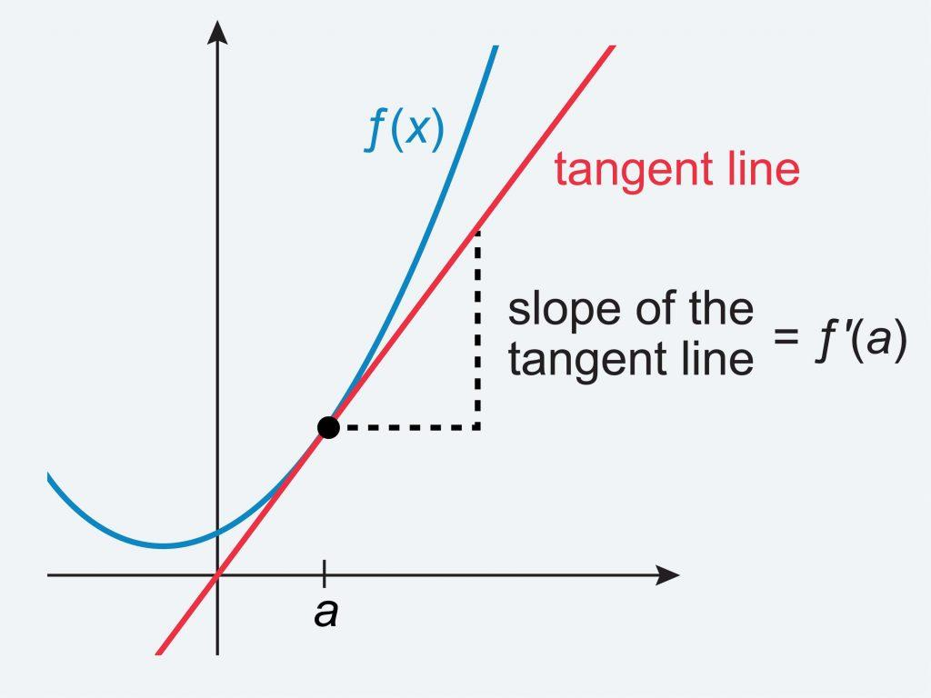
Identifying the topic
A student sees an equation but doesn't know whether they need a derivative, an integral, a limit, an area calculation, or a volume method.
App feature: A question-based topic identifier that asks what the problem is asking them to find.
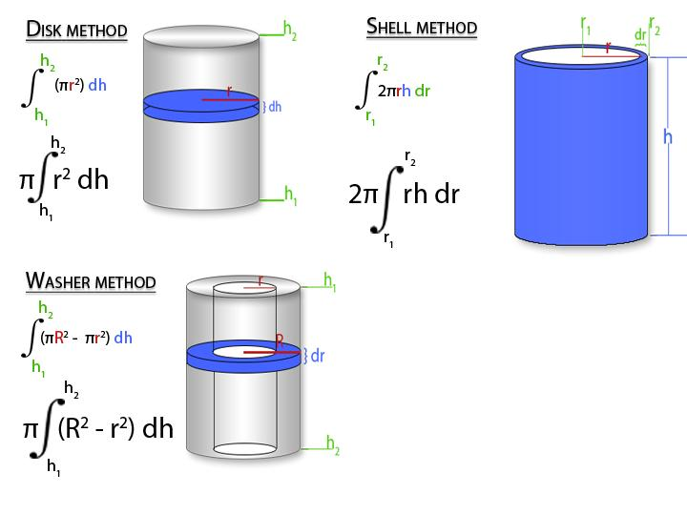
Choosing the right method
A student might recognize a volume problem but not know whether to use disks, washers, or shells.
App feature: A decision guide based on the axis of rotation, the region, and whether slices are perpendicular or parallel to that axis.
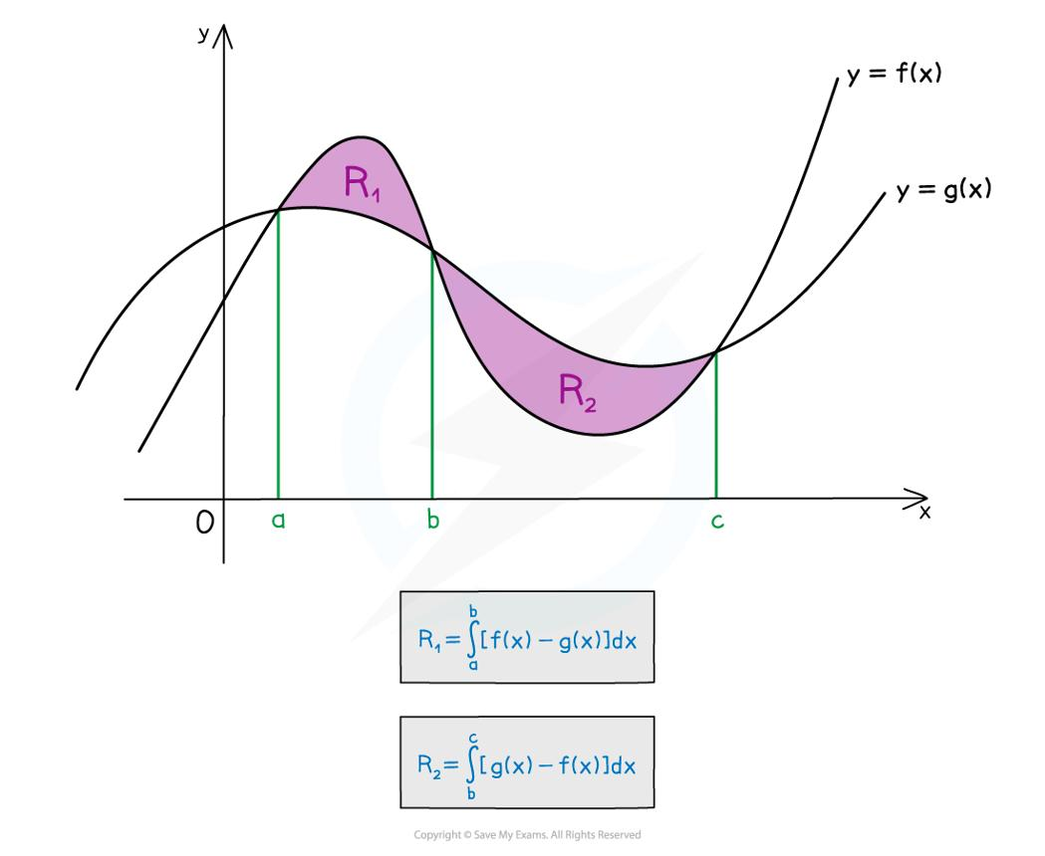
Understanding what the problem describes
Students may not know which curve is above the other, where the region starts and ends, or which variable to integrate with respect to.
App feature: An interactive graph that lets students explore intersections, boundaries, and slice direction.

2. Knowing how to start
This is probably the most important problem for your application to solve.
Students often look at a problem and immediately ask, "What formula do I use?" But before choosing a formula, they need to understand what information the problem gives them and what they need to find.
For example, consider a problem asking for the volume formed by rotating a region bounded by two curves around a vertical line.
A student might need to determine:
- Which curves define the region?
- Where do the curves intersect?
- Is the rotation axis vertical or horizontal?
- Would horizontal or vertical slices make the setup easier?
- Which method matches that choice?
Your application should guide the student through these decisions one at a time, rather than presenting all of them as a checklist they have to figure out alone.

3. Understanding why a step makes sense
A student might memorize that an integral for area is top function minus bottom function, but not understand why. They may then get confused when the functions cross or when the problem is easier to describe using
y
y instead of
x
x.
The challenge isn't always missing knowledge. Sometimes it's not knowing why a rule applies in a particular situation.
Feature idea: Whenever the student chooses an approach, the application explains the reasoning behind that choice, without carrying out the calculations.
For example, it could ask:
"You're finding the area between two curves. Which curve has the greater
y
y-value over this interval?"
If the student gets it wrong, the application could show the graph and ask them to compare the curves at a particular point.

4. Setting up the equation without making mistakes
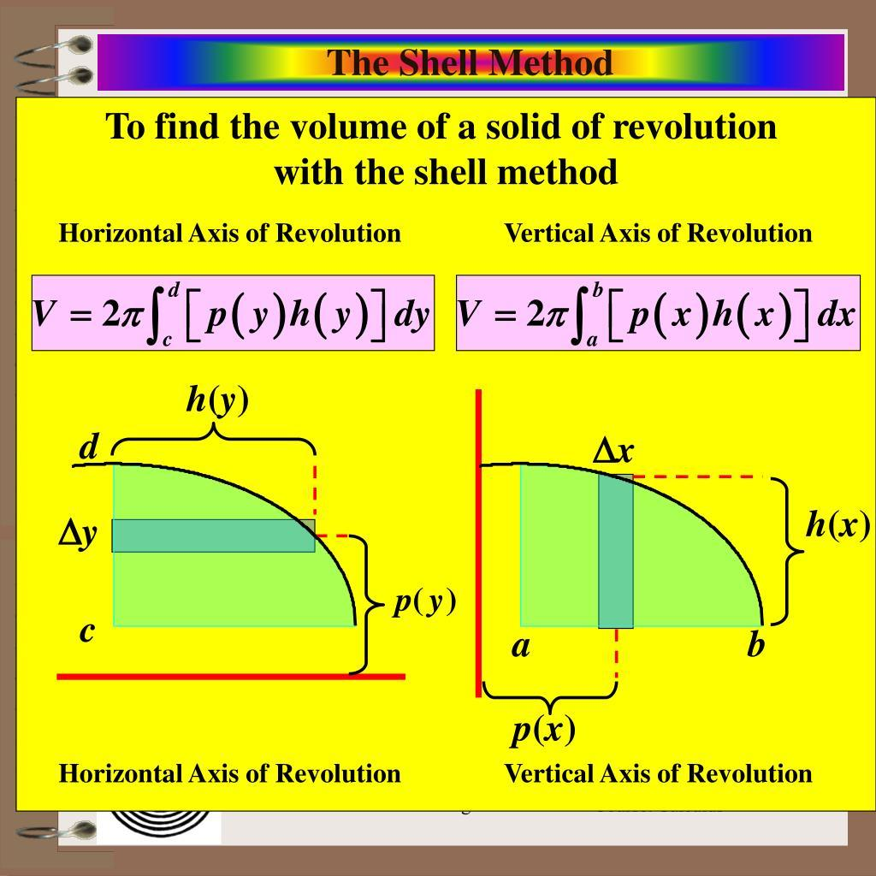
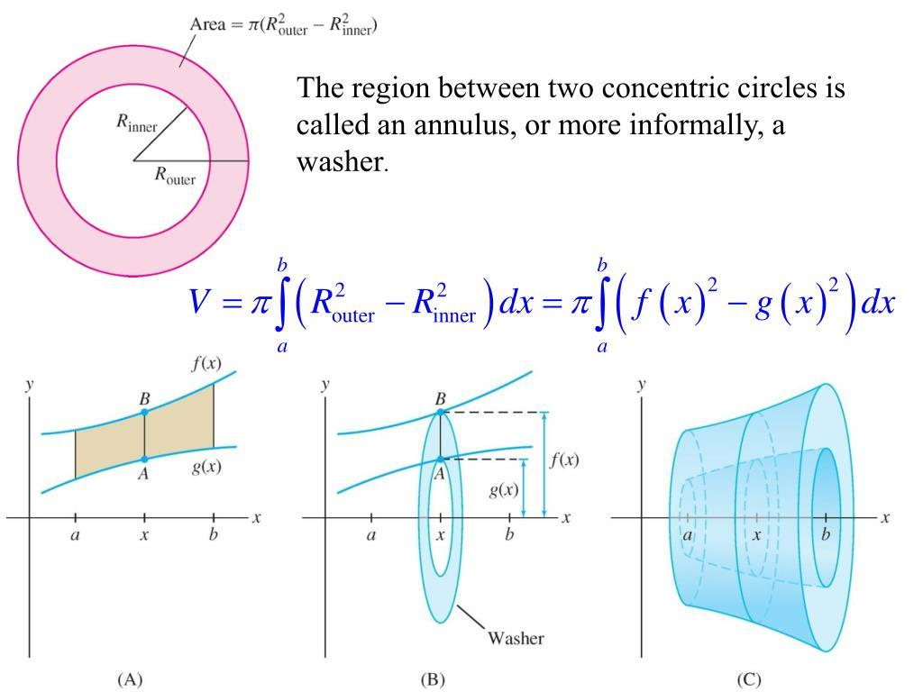
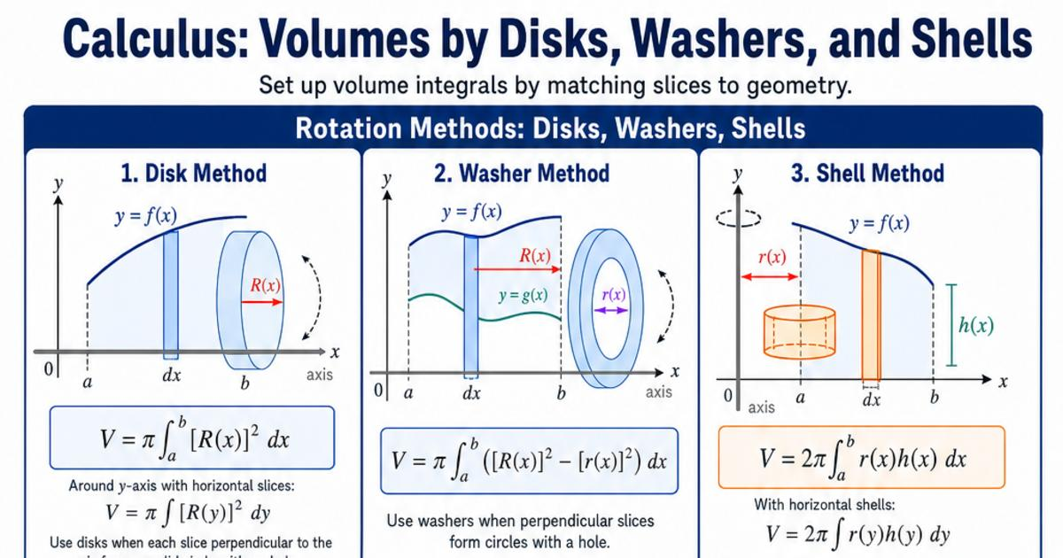
This is especially difficult in integration problems involving area and volume.
Common mistakes include:
- Mixing up
- dx
- dx and
- dy
- dy.
- Reversing the top and bottom functions.
- Using the wrong radius in a washer problem.
- Forgetting to subtract the inner radius from the outer radius before squaring them.
- Choosing the wrong integration bounds.
- Substituting into an expression without changing the bounds correctly.
Feature idea: A setup checker. The student builds the integral themselves, and your app checks individual parts without evaluating it.
For instance, the app could say:
- Topic: Volume of revolution — correct.
- Method: Washer — let's check whether your slices match the rotation axis.
- Outer radius: Revisit which curve is farther from the axis.
- Bounds: Check where the region begins and ends.
This would be much more useful than simply marking the entire answer wrong.

5. Knowing what to do when stuck
Students often don't know what they don't know. A vague hint like "use integration by parts" may not help someone who doesn't understand why integration by parts applies.
Your app should offer progressive hints: each hint provides a little more guidance than the previous one.

Example: A hint system
Sample problem: Find the area between two curves.
Hint 0 of 3
Guided help
Think about what area between two curves represents. What information would you need to measure the distance between them?
The important part is that the student chooses when to reveal more help. They stay in control of their own learning.

2. Features I would build into your web application
Here is how I would prioritize the features, starting with the ones that provide the most value.
1. Guided problem identification
Essential
The student pastes a problem or types it in. The app asks what they are being asked to find, then helps identify the relevant calculus topic and method.
The student should be able to correct the app if it misunderstands the question.
2. Interactive decision trees
Essential
Instead of giving a formula, ask targeted questions. For a volume problem, for example, ask about the axis of rotation and the orientation of the slices. Each answer determines the next question.
3. Progressive hints
Essential
Offer hints in layers: conceptual clue, relevant rule, setup guidance, and finally a check of the student's own setup. Never automatically reveal the full solution.
4. Interactive graphs
Let students see curves, shaded regions, intersection points, slice orientation, and rotation axes. Graphs can make abstract instructions much easier to understand.
5. Setup validation
Let students enter their own bounds, radii, functions, substitution, or integral. Check each component and explain the reasoning behind any error, rather than solving the problem for them.
6. Mistake patterns and personalized practice
Track which decisions students struggle with, such as choosing
dx
dx versus
dy
dy, and offer new practice problems targeting that skill. Focus on learning patterns, not just keeping scores.

3. What the student experience could look like
Imagine a student opens your application and enters:
SAMPLE STUDENT WORKFLOW

Volume of revolution
Find the volume of the region bounded by
y=x2
y=x
2
,
y=0
y=0, and
x=1
x=1, rotated about
x=−1
x=−1.
Step 1: What are you trying to find?
A derivative
An area
A volume of revolution
A limit
This is the kind of experience that makes your application different from a conventional calculator: it teaches the student how to make decisions.

4. The biggest design challenges for you as the developer
There are a few challenges worth planning for early.
Challenge | Why it matters | What I'd recommend
Recognizing the problem correctly | A problem can involve multiple concepts | Let students confirm or correct the detected topic
Giving useful hints | Hints can accidentally become complete solutions | Design a hint hierarchy with explicit limits
Checking mathematical reasoning | A correct-looking answer may use incorrect reasoning | Validate individual components, not just the final expression
Supporting different methods | Some problems have multiple valid approaches | Accept multiple correct setups where appropriate
Explaining errors clearly | "Incorrect" doesn't teach the student what to fix | Explain the specific misconception and suggest a next step
Handling graphs and notation | Images, handwritten equations, and unusual notation can be ambiguous | Start with typed equations and a limited set of supported problem types
One particularly important design decision is to avoid treating every problem as if it has only one correct method. For example, some volume problems can be solved using either shells or washers. Your app should explain the trade-offs and help the student choose, rather than claim that only one method works.

5. What I would build first
I would resist trying to support all of calculus immediately. A smaller, reliable tutor would be more useful than a broad application that gives confusing guidance.

Suggested minimum viable product (MVP)
Select the features you want in your first release.
Typed problem input
Start with a small set of supported formats.
Topic identification
Recognize area, integration, and volume problems.
Step-by-step hints
Ask questions instead of revealing solutions.
Graph visualization
Display curves and bounded regions.
Setup checker
Check bounds, radii, and integral structure.
Practice and progress tracking
Help students revisit recurring mistakes.
3 of 6 features selected
I'd start with area between curves and disk/washer/shell problems, because they involve exactly the kinds of decisions your app is meant to teach: interpreting a problem, choosing a method, identifying bounds, and setting up an integral.
You can expand into integration techniques, trigonometric substitution, derivatives, and limits later.

My biggest recommendation
Design the application around one central question:
"What should I think about next?"
Not "What is the answer?"
Every screen should help a student make one meaningful mathematical decision. When they get something wrong, explain the concept they need to revisit. When they get it right, move them forward without doing the next step for them.
That is the feature that could make your application genuinely valuable to calculus students.
Some of these steps are vary involved, like it having interactive graphs. Could you simplify it for an introductory coding project?
Absolutely! For an introductory coding project, I'd focus on a text-based calculus guide rather than trying to build a full tutoring platform. You can still make it useful without interactive graphs, AI, or complicated math tools.
The main idea is that a student enters or selects a type of problem, and your program asks questions that help them figure out where to start — without solving the problem.

1. A simpler version of your application
I'd start with just three features.
1. Problem type selector
Instead of trying to recognize equations automatically, let the student select a topic from a menu.
For example:
- Area between curves
- Disk/washer method
- Shell method
- Trigonometric substitution
2. Guided questions
After selecting a topic, the student answers a few simple questions that help them decide what to do first.
For example, for a volume problem: "Is the axis of rotation horizontal or vertical?"
3. Hints and explanations
Based on their selection, display a short explanation of the relevant concept or ask them to reconsider their choice.
Don't give the final answer or evaluate the integral for them.

2. Example of what your app could look like
Here's a simple interactive mockup of the idea.

Calculus Starting Point
Get help deciding your first step — not the final answer.
1. What kind of problem are you working on?
Area between curves
Disk/washer method
Shell method
Trigonometric substitution
2. Think about your first step
What should you examine first when choosing how to set up the volume?
The axis of rotation and slice direction
The antiderivative
The final volume
You wouldn't need to build the entire mockup at once. The point is to use a menu, conditional questions, and a few stored explanations.

3. What programming concepts would you need?
This project is a good fit for an introductory Python or beginner web development class.
Feature | Beginner coding concept
Topic menu | User input or dropdown
Different questions for each topic | if / elif / else
Checking answers | Comparisons and Boolean values
Displaying hints | Variables and conditional statements
Multiple questions | Lists and loops
Keeping the code organized | Functions, if you've learned them
You could build a very basic version in Python first, then turn it into a web application using whatever framework your class teaches.

4. What I would leave out for now
- Interactive graphs and graphing libraries.
- Automatic equation recognition.
- AI-generated hints.
- Calculating or checking complicated integrals symbolically.
- Accounts, saved progress, and databases.
- Uploading pictures of handwritten problems.
All of these could be future improvements. None is necessary to demonstrate the central idea.
My recommendation: Build a small guided-question system for just two topics first: area between curves and volume of revolution. Write three to five questions for each topic, with a hint for each. Once that works, add more topics.
That keeps the project manageable while still demonstrating a clear purpose: helping calculus students learn how to start a problem independently.

Part 8: Submit
In Google docs, with this document open, please click on File > Download > Microsoft Word (.docx), and make sure you put that download somewhere you can find it again. Then, upload it to the Canvas assignment about selecting or brainstorming your final project.

When you're done with this assignment, review this page of the Drafter documentation to better prepare for the next step.

